1. 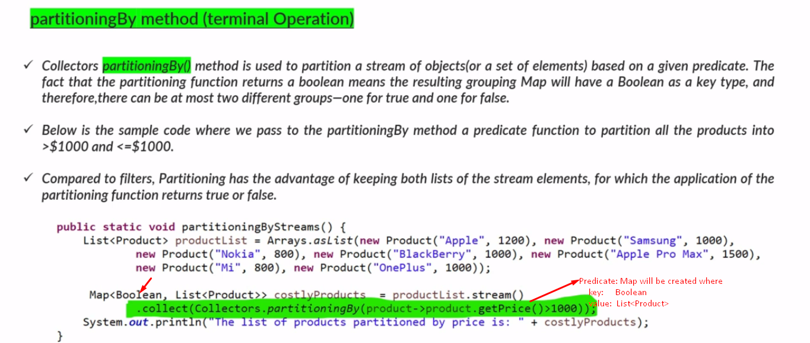
2. So you can partition your data into to categories. One which satisfying predicate and other one not satisfying.